Graphs of Exponential Functions

Key Points:
- The graph of the function $f\left(x\right)=b^{x}$ has a $y-$intercept at (0, 1), domain $(-∞, ∞)$, range $(0, ∞)$, and horizontal asymptote $y=0$.

- If $b>1$, the function is increasing. The left tail of the graph will approach the asymptote $y=0$, and the right tail will increase without bound.

- If $0<b<1$, the function is decreasing. The left tail of the graph will increase without bound, and the right tail will approach the asymptote $y=0$.

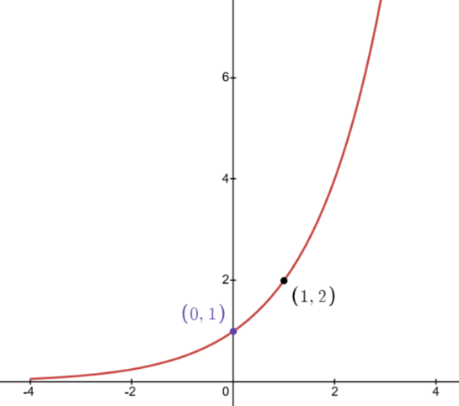
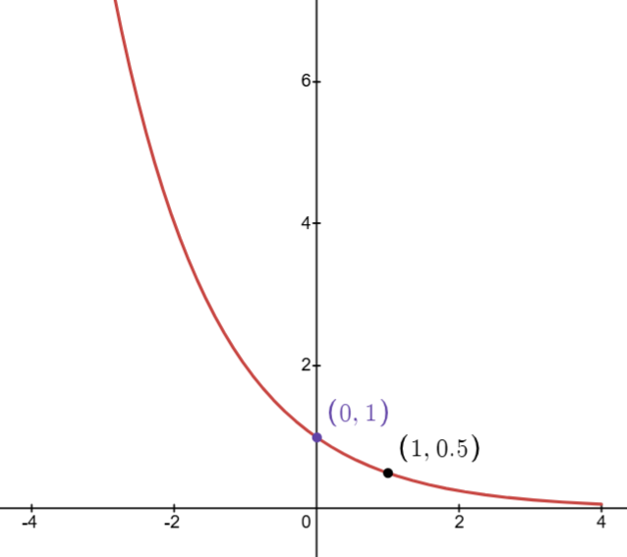
$f\left(x\right)={\frac{1}{2}}^{x}$ $f\left(x\right)=2^{x}$

- The equation $f\left(x\right)=b^{x}+d$ represents a vertical shift of the parent function $f\left(x\right)=b^{x}$.

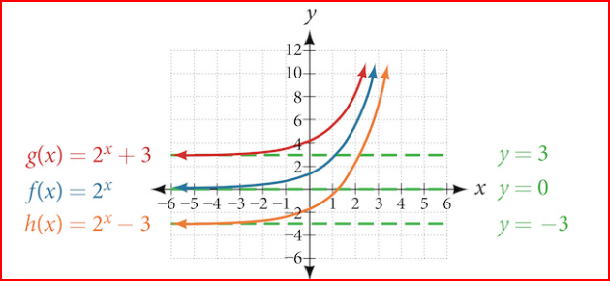

- The equation $f\left(x\right)= b^{x+c}$ represents a horizontal shift of the parent function $f\left(x\right)=b^{x}$.

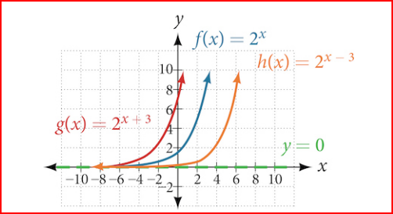

- The equation $f\left(x\right)=ab^{x}$, where $a>0$, represents a vertical stretch if $\left|a\right|>1$ or compression if $0<\left|a\right|<1$ of the parent function $f\left(x\right)=b^{x}$.

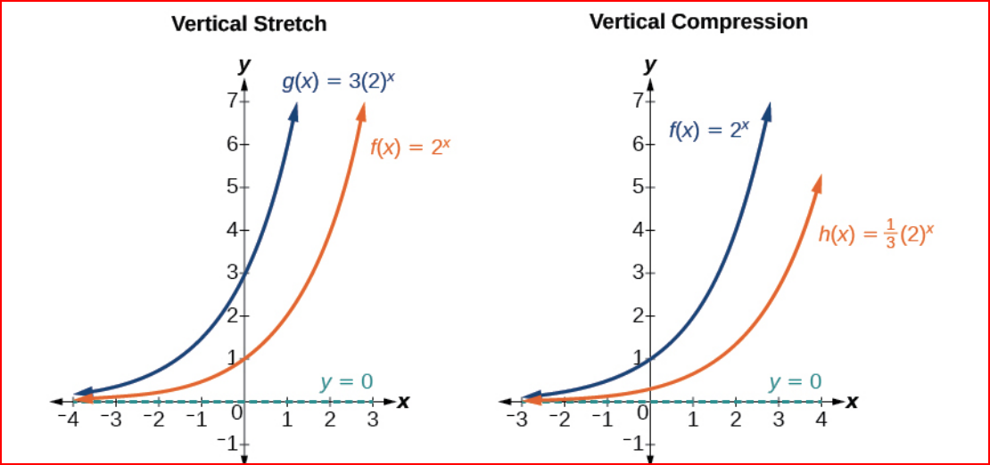

- When the parent function $f\left(x\right)=b^{x}$ is multiplied by -1, the result, $f\left(x\right)={-b}^{x}$, is a reflection about the x-axis. When the input is multiplied by -1, the result, $f\left(x\right)=b^{-x}$, is a reflection about the y-axis.

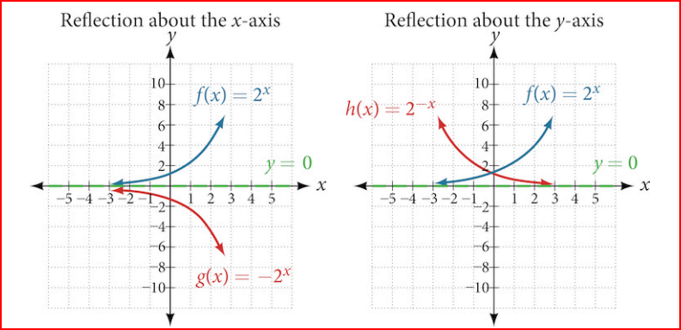

Graphs of Exponential Functions Videos
- Sketching the Graph of an Exponential Function of the form f(x)=b^x: Example 1
- Sketching Transformations of Exponential Functions: Shifts- Example 2
- Sketching Transformations of Exponential Functions: Vertical Compression-Example 3
- Sketching Transformations of Exponential Functions: Vertical Stretch- Example 4
- Transformation of Exponential Function: Reflection-Example 5
- Writing a Function from Description-Example 6

Practice Exercises
Follow the directions for each exercise below:
- Graph the function $f\left(x\right)=3.5{(2)}^{x}$. State the domain and range and give the y-intercept.

- Graph the function $f\left(x\right)=4{\left(\frac{1}{8}\right)}^{x}$ and its reflection about the y-axis on the same axes, and give the y-intercept.

- The graph of $f\left(x\right)={6.5}^{x}$ is reflected about the y-axis and stretched vertically by a factor of 7. What is the equation of the new function, $g(x)$? State its y-intercept, domain, and range.
- The graph below shows transformations of the graph $y=2^{x}$. What is the equation for the transformation?
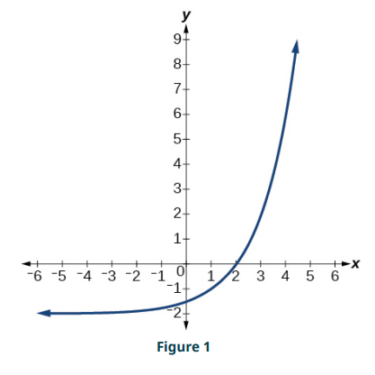

- Graph the function $f\left(x\right)=5{(0.5)}^{x}$ and its reflection across the y-axis on the same axes, and give the y-intercept.

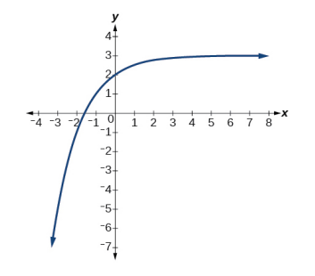
- The graph shows transformations of the graph of $f\left(x\right)={\left(\frac{1}{2}\right)}^{x}$. What is the equation for the transformation?

Answers:
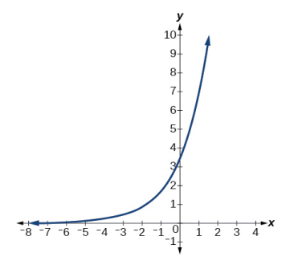
- Domain: all real numbers; range: all real numbers strictly greater than zero; y-intercept: (0, 3.5);

- $y-$-intercept: (0,4);

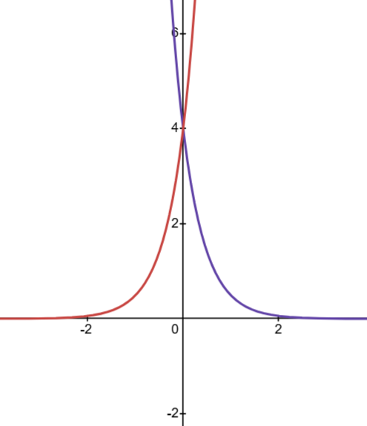
$$f\left(x\right)=4{\left(\frac{1}{8}\right)}^{x}$$
$$f\left(-x\right)=4{\left(\frac{1}{8}\right)}^{-x}$$

- $g\left(x\right)=7{(6.5)}^{-x}$; y-intercept: (0, 7); domain: all real numbers; range: all real numbers greater than zero.

- $g\left(x\right)= \frac{1}{2}{(2)}^{x}-2$

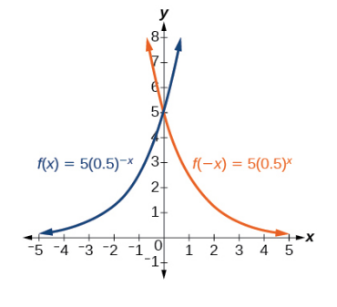
- $y$-intercept: (0, 5);

- $g\left(x\right)=-{\left(\frac{1}{2}\right)}^{x}+3$

